血色艳丽 王庆松栗宪庭对谈录
栗：1995年秋冬之际，我陪德国波恩艺术博物馆看艺术家时，我看到你的那批人体作品，后来那批作品参加了1996年波恩艺术博物馆的CHINA!展览。那是你最早的作品吧，画面很表现主义，构图很满，人体画得很扭曲，很压抑，是一种情绪的宣泄。接着就是1996年5月，你参加了早期艳俗艺术的集结展览《艳妆生活》。大家开始知道你，是因为你做艳俗艺术，但你是从画那种压抑、扭曲的人体，转变到画丝绒艳俗风格的画，关注的是一种社会的审美趣味，从内心宣泄转向了看外界，这是两种完全不同的方式和艺术态度。你谈谈这个转折的过程吧。
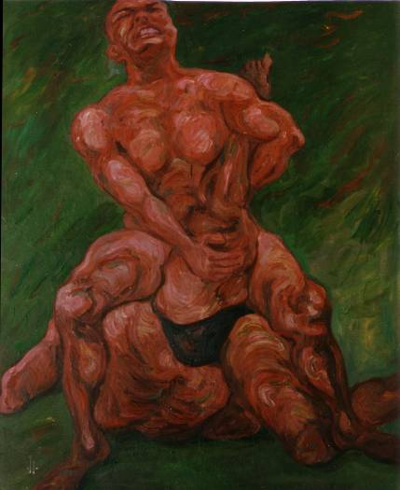 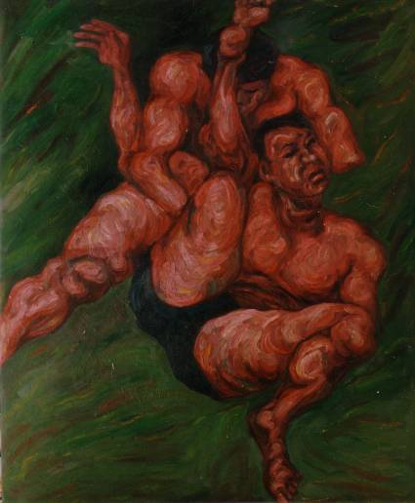 《竞争》系列作品，油画，1994

王：1993年我到北京，来之前还在想要不要创作啊，希望画一些好的作品，参加全国美展，进入当时主流的艺术圈子。我口袋里装了1200元钱，跟着一个老家的画画的朋友一起来北京的。原以为这些钱可以过半年，可两个月就花完了。冬天来了，我找那个朋友的姐姐，她在国际关系学院工作，想跟她要个褥子也得不到。后来大冬天的我只能放个床单，什么都不敢买。

刚来北京，我没住圆明园，住在离圆明园比较远的一个村子里面。那里只有我一个人是画画的。生活和心理压力搞得我特别难受，总觉得社会上的竞争太复杂了，所以那段时间画了一批人们摔跤打架的作品。但是画着画着就觉得不对头了，因为社会变了，并不是简单的血淋淋的暴力。

1993年以后，整个社会变化非常快，人的状态彻底改变了。现实要求我不可能只表达个人的感受。我开始考虑社会为什么这样变，这样从最初的日记式的油画创作，进入到报告文学式的艳俗艺术创作，可以更宽泛地看待社会的各种变化。

栗：这个我谈艳俗的时候说过，艳俗是社会审美趣味上的。

王：对。在绘画形式上或者艺术形式上，艳俗的东西表面上看好像很矛盾。在圆明园，我有一整年没有做作品。原来画的画也全部反靠在房间的角落里，没有人知道我画的是什么，我自己也不想看。那时候更多的时间都是在交流，跟徐一晖他们一起。大家都有一种感觉，就是没法再画下去了。社会变化的这种压力远远超过我们内心的郁闷情绪。大家慢慢地都往这个方向开始变了。看似很突然，其实是有一个过程的，就是在不动笔的那一年才慢慢转换过来的。

栗：1996年5月份，我做了《大众样板》的展览，有徐一晖，王劲松，祁志龙。那时圆明园的一批画家画艳俗风格，但没有他们三人的作品成熟，但紧接着杨卫他们组织其他人一起展览，找我起名字，我起了《艳妆生活》。那就是你第一次登上这个舞台，大家才看到你的作品，最开始你就用丝绒画，我谈艳俗的时候就谈到，那时候很多画家开始用民间的东西，民间题材—白菜、萝卜这种最世俗化的物象，还有在材料和画法上特别强调和民间艺术的关系，比如常徐功使用刺绣，还有其他很多人的，都跟时尚、通俗有关系，你选择了丝绒画。丝绒画本来就是非常民间化的一种样式。这和美国六十到八十年代的变化有相似的东西，从波普到杰夫·昆斯（Jeff Koons），昆斯作品使用很多民间工艺。你可以谈谈这批画最初的一些想法。
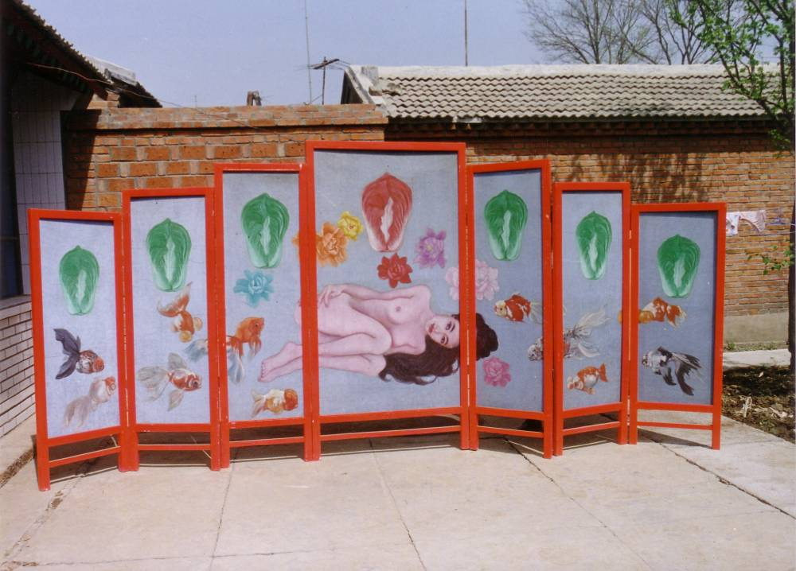
王：最早的时候也是在油画布上画，但是后来觉得画布上有很多局限。当时画的也不太如意，总想变一下，只是不知道要画些什么，或者画在什么材料上。首先我不想再画在油画布上，但画在什么上面还得继续找。那时玩世、政治波普已经非常稳定了，基本上最经典的作品已经全部创作出来了。所以如果要想在绘画上独立出来，必须要摆脱油画，首先要摆脱油画布。

栗：你同时摆脱了油画布和油画笔触等模式。

王：对，这是第一步。原来我在江汉油田工作的时候，在金丝绒布上给单位的领导和朋友画过小猫小狗的，完全是那些民间的图象，他们都很喜欢。尽管丝绒画挺好，可是绷在画框上还是脱离不了油画效果，所以我就要找一种展示形式，这样才选用屏风，它更家庭化、民间化，不像艺术。后来看书的时候知道美国八十年代也有艺术家用天鹅绒，可当时在国内并不知道，因为看不着什么资料。丝绒画在中国肯定不是八十年代的事儿，很久之前就有的，所以不存在学不学谁的问题。但是丝绒油画表面金灿灿的，有种特别假的真实感。那时候就确定，这东西可能是我将来的方向。1996年，北京第一次展览的就是那个时期屏风的作品。屏风的边框上贴了很多小学生玩的明星头像，表面上刷了清漆。虽然屏风是很传统的，但是现代的东西在上面。当时考虑的是必须改变原来那种惯性的材料和展示方法，而且选择的还必须是非常庸俗、大众化的东西。

栗：这个完了就是照片了吗？

王：中间又画了一些人被塑料布包裹的油画。1995年左右，我从圆明园搬到香山，因为附近是军事基地，必须搬走，就这么来回游动，又陷入一种失落。社会啊、艳俗啊什么的又离我很远了。这时候马上就感觉到艺术不重要，生活更重要。

那时候画裹在塑料布里的人是因为自己感觉特压抑。塑料布是透明的，所有外界的东西都可以看到，但是人是压抑的，所有外界的好坏都跟自己没关系，所以一下子心里特别难受，又出现了这种矛盾的心情。我知道那不是我要表达的艺术，但真的是直觉。就像你想做一件事情，别人不让你做，故意干扰你的生活。那年我搬了五次家，不断被房东刁难，那段时间就又回头画人被塑料布裹着的东西。
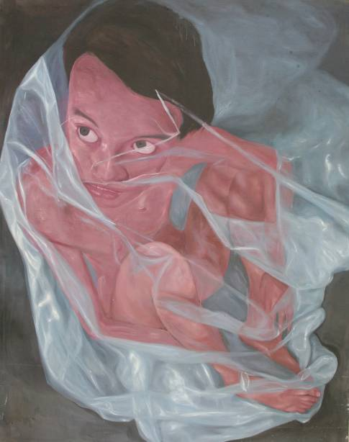 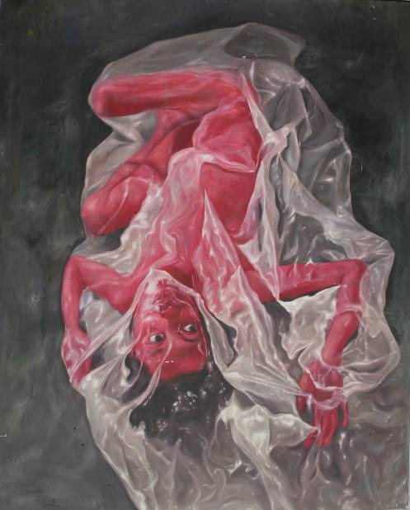 《失语》，油画，1996
栗：人被塑料布裹着是在哪里开始画的？

王：实际上从1995年圆明园搬出来之后就开始画，一直画到1996年底。

栗：那段时间挺长的，从圆明园出来之后，到香山，到宋庄，后来到东坝河。

王：1997年搬到东坝河其实已经不画了，那时候觉得又缓过来了。有了住的地方就有安全感了，而且有了女朋友。

栗：视点一直在内心和外界转折和犹豫。

王：对，矛盾永远在搅和你。但是心里一直在考虑很多问题，包括技术问题。我一边做屏风，一边画塑料布里边的人，一直在左右摆动。但是我觉得它们两个有关系，又特别矛盾。那几年最难受，包括生活上和艺术上。宋庄最后一次搬家是1997年元旦。大雪天的，被人堵在家里，让我搬家。要不搬家就把我抓到派出所或者送到精神病院，那时候听了这句话心里特难受。1997年初搬到东坝河，开始接触那种小市民的生活，又进入艳俗那种状态。回到城市里面感觉安全了，也经常去酒吧了，来的朋友多了，对话的机会也多了。这时才开始做图片，当时是用A4纸打印出来。

栗：第一个做的是什么？

王：就是当时商场里流行的那种，用电脑把自己的头放在明星身上。最早做的图片是《三姐妹》和《中国英雄》。
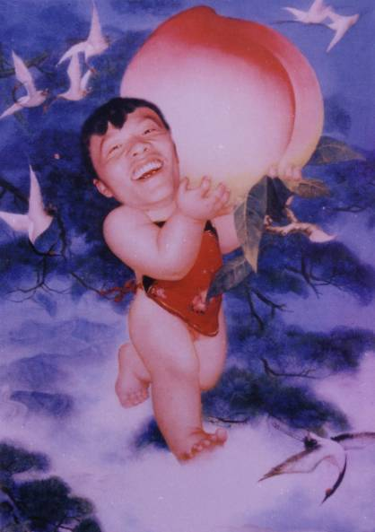
栗：那个还是很民间风格的，跟屏风也有关系。

王：对，它是一种延续，但是希望用另一种方法去展示。图片的第一次展览就是1998年台北双年展，当时是喷在丝绒布上的。因为喷绘的会掉色，而且经常换喷头，喷头毁得很快，人家不给做了，所以必须再找方法。接着找到了一种像镜面一样光滑有金属质感的材料，我把图喷在那上面。2000年参加光州双年展的时候就是用这种方法，两头用国画挂轴装裱起来。但是韩国展出后出现了问题。 那时候还是想追求一种展示形式。2000年底在北京云峰画苑办展览请你写短评的时候，我已经完全想明白了，为什么非要追求像屏风啊、国画卷轴啊的效果呢？那种东西太表面了。可能图像本身就能解决很多问题，创作风格是最有魅力的。

栗：你比较大型正规的创作应该是从《老栗夜宴图》开始？
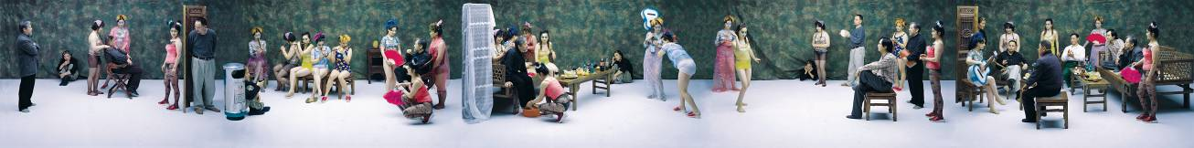
王：对。那张我觉得有点近似赌博了。如果最后一次还不能呈现我的真正的想法，那肯定是再也没有能力去做了。1999年到2000年我在北京和家之间来回跑了六趟。当时为了筹药费给我妈治病，把塑料布那些油画基本全都卖了。我妈临终前说把她补发的工资、抚恤金全都留给我。所以拍《夜宴图》用的就是我妈的钱，还有张芳的奖学金。拍之前其实我一直想找老郭（伊灵）的，但是觉得老郭有点匪气，不像知识分子。后来想找肖丰，肖丰的感觉也不够，胡子长得不太像，也没有那种沧桑的感觉。后来廖雯说怎么不找老栗试试，我一听，哎吆，这个好。2000年是整个国内艺术界刚刚开始进入转型的阶段，我从你的眼神里可以看得出那种比较忧伤的感觉，你的那种状态很像韩熙载。

栗：我也对顾闳中那张画，韩熙载这个人很熟悉。我知道他当时的社会背景和心理状态，韩熙载为什么故意那样沉醉于糜烂的生活中，和他自己的忧虑都有关系。

王：对。当时你问我，“你了解《韩熙载夜宴图》吗”。你说你给任小林写过一段文章，提到《韩熙载夜宴图》。但是我没有看过你那篇文章。因为要拍《韩熙载夜宴图》，我还是看了很多书。我希望表达一种既有知识分子寒酸的一面，又反映社会糜烂的一面，希望有双面性。

栗：顾闳中本来就是要以糜烂的生活来迷惑李后主，表示他没有野心，但实际上他对王朝已经非常得忧心忡忡了。

王：对。确实主人翁后来都是很悲剧化的结尾，包括李煜最后也很悲剧性地自杀。当时我特别想告诉你我会怎么去完善这件作品，但同时我又不敢说。我一说，万一你把我否了，还有一个星期就要拍，所有的道具都买了，你把我否了可就麻烦了。拍完之后，实际上我就没钱了，只剩三百块钱。我不知道你还记不记得当时那个底片装反了。当时摄影师说加密冲一下就行了。幸亏没加密，加密根本就出不来，因为反面没有药膜，感光材料都没有。当时发现出了问题后，我马上就跟肖丰商量，决定再重拍一次。

栗：后来是重新拍的是吗？

王：是，重新拍的。当天下午是萧昱和王音他们在老焦的空间办展览。你还要赶去参加他们的展览开幕。当时我想完蛋了，没时间重拍了，老天要把我毁了。

栗：后来拍了两次吧？因为我记得那天拍摄，我起的很早。

王：对，那天晚上你没睡觉。头一天是任小林的生日，许多艺术家都在花家地西里给小林过生日。因为第二天早上要拍，我心里急。你说：“庆松，你放心，没事，没问题的，再等等”。我对自己说“没关系，没关系”。但回家已经是三点多了。你说：“庆松，你先睡。我今晚就看书了，不睡了。”所以那天晚上你是没睡的，我是睡沙发上，心想万一你要休息，你就睡床上。那天你问我几点钟叫醒我，我说七点钟，因为八点钟开始拍。从早上八点开始，拍到下午三、四点左右，胶片拍到最后一张卡壳了，抽不出来了，这时才发现底片装反了。后来重拍，根本没有时间换服装。所以现在所看的五个镜头，服装是没换的。最初的五个镜头的服装是有变化的。那时候的效果更好，表演是表演的服装，请客是请客的服装，而你的服装却没有变化。

栗：我改了一个细节，顾闳中是洗手，我说咱们改成洗脚吧。

王：对。当时我一直想解决这个问题。洗手把后面的人都挡住了。你建议洗脚，这样前面的人就蹲下了，一蹲下全部问题就解决了。不过当时没真洗，袜子都没脱。冲完底片后，我拿一张底片是空的，拿一张是空的，前面都是空的。后来闭着眼睛随便拿一张，一看有图。赶快就翻，但是还是非常遗憾，每个底片都切镜头了，不太完整。我租的是三扇屏风，可只拍上了一扇，其它两扇没拍到。

栗：当时你是有点保守了，依我是再等几天，我把张小刚、王广义、方力钧全约过来，一起拍。

王：对。当时你说过这个想法。可我骨子里还是希望摆脱原来的东西，希望变！为什么拍照片就是因为不想画画了。当然你想的也很好。但对我来说想请他们很难的，至少也要请人吃饭。而且最重要的是我希望去表现这个社会的色情、糜烂的东西，想把这些东西加强突出表现出来。

栗：你那些丑模特挺好的。

王：对。当时连影棚的厨师和家具的主人都参与了拍摄。那些人穿着很俗气，可形象很好，视觉冲力力很大。而你是那种很传统的中国文人的形象，和世俗有着很大的反差。如果全是类似你这样的形象，那些模特也起不到衬托的作用。作品扫描制作完成后，我从电脑上看，你的那个表情特别好，很忧伤，同时也有很疲劳的感觉，因为头一天晚上根本就没睡觉。幸好没有让老郭演这个角色，老郭真的看上去有点匪气。也不能用肖丰，肖丰演的是另外一个角色，他有点太书生的感觉。拍完后我非常满意，虽然没拍完整，有的画面被切掉了，但我觉得特别满意了。后来创作的胆子就大了，好像可以继续做。我后来想胶片根本不可能报废，因为那是用死人的钱，鬼都拉不走。它不能失败，一定要成功。而且特别巧，我收到2000年光州双年展邀请的那一天，正是我妈去世的当天。太邪了！

栗：因为他们在台北双年展看到了你的作品。

王：对。

栗：别人也问我：“老栗，你是那样生活的吗？”我问：“你相信吗？”

王：《老栗夜宴图》的成功也带来了很多骂名。我很矛盾，但我特别喜欢那个图。不要说老栗你是名人，哪怕你是普通人，那种表情还是非常生动有感觉的。后来这件作品宣传越来越多，骂我的人有一次跟我聊天，说：“庆松，这图真的很好。假设我不认识老栗，这不是老栗的话，它也是很好的一个图。”当时在摄影里面，这个作品算是场面比较大，比较完整的。我觉得这个作品最重要的是它给我以后的作品一种信心，告诉我可以继续做。

栗：这个完了之后，就开始了你和女孩一起在澡堂子洗澡，大家一起看天上的可乐这些作品了吗？

王：对，真的随心所欲，可以放松，可以延续。

栗：这些东西都跟时尚的消费是有关系的。但是你突然拍了这套作品《又一次战争》，这些东西稍微发生了一些变化，不仅仅是幽默、反讽的，而开始关注消费文化到中国以后，中国人心理上的战争。解释你这组战争作品的时候，我会这样去解释，中国人对这种消费文化的态度是爱恨相交的，内心打架。它既是一种消费文化和中国原来文化的对立和战争，也是每个中国人内心的一种战争。
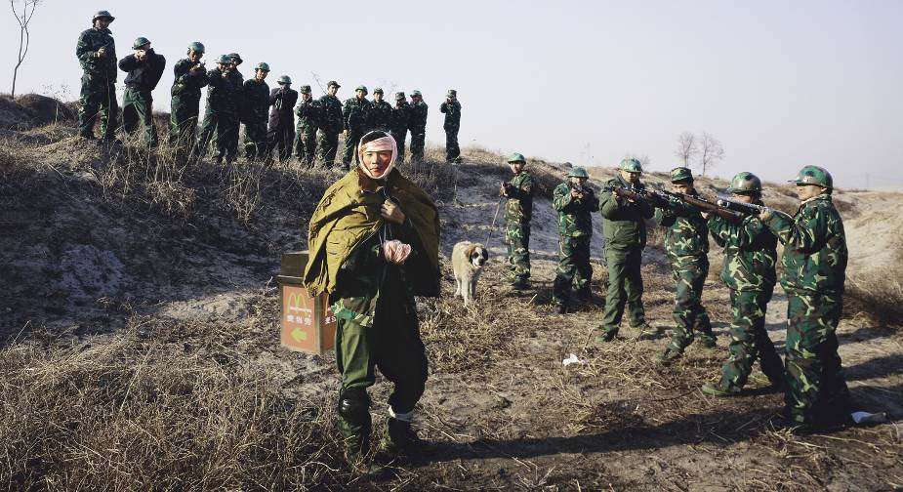
王：对，确实是，我也是这种意思。他进攻的同时，其实也是负伤的，受伤害也是想表现这种爱跟恨的矛盾。很多中国人喜欢西方快餐，至少表面上感觉很干净。尤其在北方，早餐没有多少东西，也很少小吃，即使有，也很脏。西方消费文化真的改变了很多传统的东西，破坏传统的痕迹很重，但是我们似乎又有点离不开它。因为《老栗夜宴图》遭到了很多非议，说我在利用老栗，所以我就想我应该改变，找另一种方法，当然场面也不能小，不能比《老栗夜宴图》小，于是那个时候接着拍了《过去、现在和将来》雕塑和《又一次战争》。
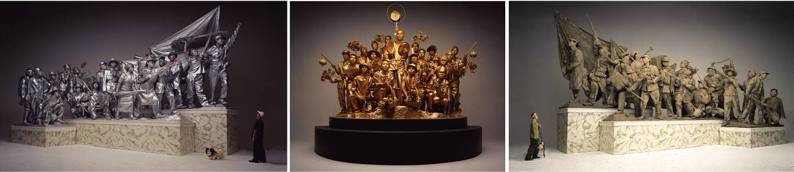
栗：是和战争系列同一年拍的吗？

王：对，那是一年拍的。

栗：这两件作品其实又是个转折，它们都是比较重量级的作品。

王：对。当时骨子里是想，这次不能用名人，也不能有花里胡哨的感觉，我要改变。本来《过去，现在和将来》和《又一次战争》是再等几年拍的。最早是想把艳俗继续延续一两年，但后来必须马上把它断掉，赶快提前变化。当然拍战争的时候也不是太如意，本来原计划希望做的更大一点，更有意思一点。但是由于那一年法轮功开始自焚，所有的地方烟火禁售，根本买不到烟火。我选的拍摄场地在燕郊，那个地方是东北法轮功的必经之道，如果放烟大的话，会出现问题。拍的那天，警车来了，警察在坡上看。之前我已经有意识地把北京电影制片厂的烟火箱子放在入口的地方，而且也把租的公交车停在显眼的地方。他们一看以为是拍电影的，就撤了。这两件作品从想法上，我希望表达跟现实生活有关系、离现实更近一点的东西，表现社会更平实的一方面。

栗：我解释《过去、现在和将来》，这个东西更重要，因为这个我还跟西方的批评家讨论过这个问题，这件雕塑的样式是所有社会主义阵营里面经典模式，它是个非常具有冷战时期的代表符号，很意识形态化，很集体意识。但你又从时尚的角度去转换这种雕塑模式，等于说我们现在的时尚，经济的开放，包含和反讽的不是真正的经济开放，真正的商业文化。它实际是意识形态的一种改头换面。

王：对，那个图当时拍的时候，我大的感觉是有的，但用什么形式，用什么方法去拍，其实并不清晰。1997年香港回归以后，我就开始注意天安门的变化。每年国庆期间我都拍天安门的很多变化，那时去天安门的机会就多一点。当时经常看到很多人在天安门广场、毛主席纪念堂前面嘻嘻哈哈、模仿英雄们的动作。中国人也做，外国人也做。单位、集体的代表们到北京开会，参观天安门广场时全做这个动作。我开始疑惑国家机关的人怎么也会对英雄都没有敬畏感了，庄严的英雄雕塑都变成到此一游留影的道具了。这个社会难道真的变了，价值观都没有了吗？

栗：变与不变的因素都有。

王：所以当时就想去做这个作品。用什么方法，还不清楚，就是希望表现这样一个变化的过程，从过去、现在到将来。我也查阅了许多苏联的城市雕塑的画册。如果从艺术表现力上来说，苏联做的是最好的，剩下的是中国、朝鲜。但是从形式上看，中国比苏联做得更完整，朝鲜比中国做得还要疯狂，还要细。除了天安门广场，沈阳还有一个。

栗：那个是最早的，1970年代初期。

王：对，那个雕塑更加简练，更生活化了。但天安门的雕塑感觉更“艺术”或者更概念一些。

栗：沈阳红旗广场的那组雕塑更疯狂，有的形象从一堆里面突然探出来，好像冲向观众。

王：扛着真实的大油管子。

栗：好像叫毛泽东思想万岁吧？

王：当时我没有去，我让朋友在那里拍了很多资料照片，寄回来看，好找找感觉。但是照片拍的有点滑稽，雕塑的旁边有很多大型广告。我觉得这个是很有意思的，理想与现实的反差更促进了我把这种理想丧失的东西要表达出来。那时候其实已经开始用摄影的方法了，真的不在乎什么东西了。

栗：这个完了之后是什么？

王：拍完这两个，我感觉有点累了，2002年之后，就开始拍小的东西，有《卖货郎》，小孩儿刚一岁嘛，就拍一个跟自己孩子有关系的作品。其实就是为了2003年以后做的准备。当时之所以选这个作品倒不是说对古画多迷恋，就像拍《老栗夜宴图》是表现知识分子的问题，《我能跟您合作吗？》是表现外交的，当时李世民就是这样。这个《卖货郎》是表现孩子的教育问题。我希望表现从古代到现代的变化。有时候也会拍一些小的合影的东西。2003年又拍了一些肉花。
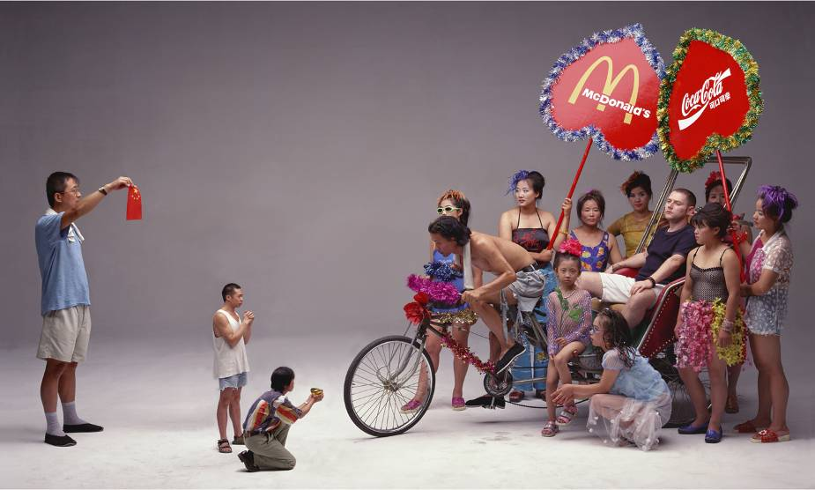 《我能跟您合作吗？》
栗：这批作品里边那个肉花是比较特别的。你可以重点说一下那个肉花吗？

王：我有时候做作品也不完全是为了艺术。有的朋友就说，“你老拍那种大场面的人，你能拍不带人的吗？”我其实一直也想拍一些不带人的作品。社会到处是欣欣向荣的景象，于是我想拍一幅看上去很美的花的作品。当时很多大酒店里都挂国色天香的牡丹图，中旅大厦那张就是很经典的。当时想美丽的东西肯定带有伤感的东西。我觉得就是那种肉的感觉。刚开始肉是很鲜很硬的，等到它软了、化了，噼里啪啦往下滴血的时候，我才开始让摄影师拍的。这也象征着人的一种理想在经历考验和侵蚀。
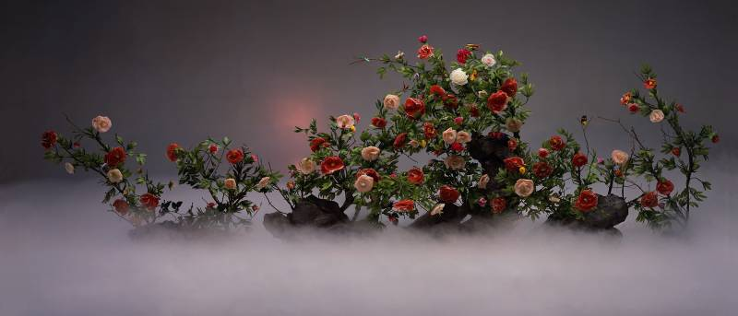 《国色天香》
因为中国传统中就说梅花如果能顶过冬天的寒气，第二年可能会生长得更茁壮。牡丹花也象征着人的一种壮志，像知识分子的风格。其实我更喜欢国画里边没人的感觉，山水画里边有几个特别小的人也特别让人寒心。所以我是希望你看这个作品的时候，视觉上觉得很美，但是心里头觉得很寒心。当然也是有意识地强加这种寒冷，我把肉花再冻起来，冻跟不冻前后进行比较。也许这些花 （代表理想）经过寒冬，第二年更旺盛了，或许也会被冻死了。拍的时候，我还打上干冰来加强那种迷幻的效果。同时背景布后面也加上隐隐约约的阳光，表现还是有希望的。
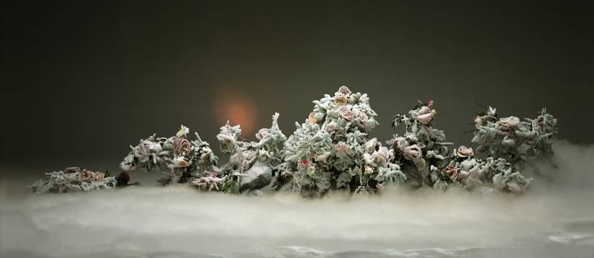 《瑞雪丰年》
拍完以后我很喜欢这个作品的，当然也有人说我拍人更好。我感觉这个作品又重新回到我本能的东西，日记性的东西。因为我本性上就是不太跟人交流的，骨子里是比较内向的，所以我特别喜欢这件作品。

栗：我也是最喜欢这件作品。其它的那些都可以，就是比较泛泛的那种，像拆房子啊，广告啊，商品啊，普遍的那种社会问题的关注。
王：别的作品里面可能还有给别人看的成分，就是我展现给人看，想跟人交流。这个肉花的作品就是我自己内心想的，比如我喜欢吃川菜我就吃川菜，而不是陪客人吃饭的时候我要征求别人的意见。艺术作品有时到了一定程度不一定非要说真话，谎话有时候也要去说，但同时就是说真话的时候，你自己最清楚。很多人觉得肉花的作品不好，他们觉得社会应该是怎样怎样的，可我觉得没那么简单。

栗：说说2006年你那个战争的作品，只可惜我们不能看到。
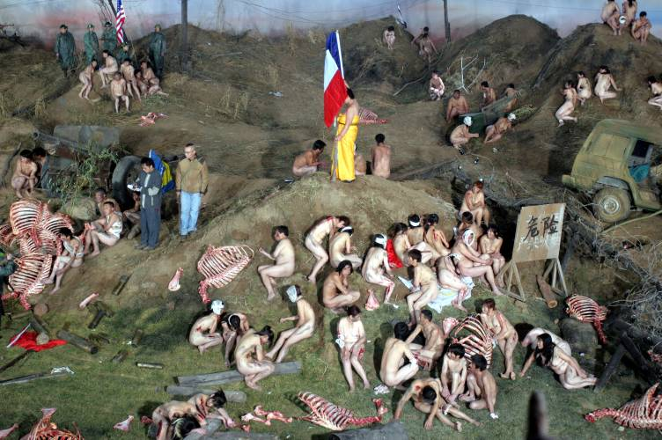 《世界的血》工作照

王：那个作品现在当然还不能肯定有没有结果，但是拍完以后，我觉得特别满意。 现在每个国家、每个角落都存在着各种各样的冲突，每个人都似乎感觉到世界大战要来临的恐慌，所以我想综合一下许多残酷血腥的战争场面。在这件作品中，我把世界上各个时期、各种各样的战争画面搅和在一起，它有点滑稽，有点压抑。我想尽管现在社会表面上看很好，大家都比原来更有钱了，房子也住得更大了，可不知道是不是内心里面真的感觉这么好。可能每个人心中都有场战争，对自己有一场战争，对邻居有一场战争，所以战争应该是个更宽泛的概念。我一直希望我的作品像看图识字一样，尽量直白一点，看到名称就能明白我的作品的一半。当时这件作品我想取名叫《世界的血》，特别直接。当然我希望这件作品以后能够出来。

栗：有没有想过重拍？

王：肯定不想重拍，因为很难，而且情绪上肯定也不对了。这个作品其实已经完成了，它是否存在固然很重要，但是因为我把自己的话也说出来了，我觉得也只有等待。好多人也为我惋惜。对我来说，最重要的不是这件作品，而是它会不会对我的将来作品有影响，比方说演员还会和我合作吗？别人还敢不敢租给我场地……，这些才是我最关心的。
Sanguine Splendor
A dialogue between Wang Qingsong and Li Xianting

Li Xianting: The first work of yours I saw was that figure series while searching for artists on behalf of the German Kunstmuseum Bonn at the end of 2006. This series was consequently featured in the Kunstmuseum Bonn's "CHINA!" exhibition in 2006. That early work was very expressionist, the bodies appeared twisted and oppressed - it seemed like an emotional vent. This was followed in May 1996 by your participation in one of the first Gaudy Art group exhibitions, "Gaudy Life". It was because of your gaudy artworks that people first knew of you but in fact you had previously been painting oppressed, twisted human figures before turning to those gaudy pictures on velvet where you began looking at society's aesthetic taste. You had gone from introspection to looking at the outside world; these were two entirely different styles and artistic positions. Please tell me about how this shift came about.

Wang Qingsong: Before I came to Beijing in 1993 I was wondering whether or not I should keep going with art. I wanted to paint something really good, to take part in national exhibitions, and get into mainstream art circles. I had 1200 yuan in my pocket and came up to Beijing with another artist friend from back home. I thought the money would last me six months, but after only two I had spent it all. Winter came and I went to my friend's sister who was working at the School of International Relations. I asked her for a padded mattress but she wouldn't give me one. That winter I only had a sheet to sleep on, and didn't dare to buy anything.

When I first came to Beijing I wasn't living in the Old Summer Palace area - I lived in a village quite a long way from there. I was the only artist there. Life was tough and I suffered psychologically. I felt that our society was too competitive, and so in that period I painted people wrestling or fighting. But as I went on painting, I started to feel that something wasn't quite right. Society had changed and it wasn't as simple as just bloody violence.

Starting in 1993, society began changing extremely fast. People totally changed too. Reality demanded that I couldn't just go on expressing my own feelings. I needed to think about why society was like this. That was how I went from painting diary-style oil paintings to more gaudy artistic creations in the style of reportage, thereby tackling the changes in society in a much broader way.

Li: I discussed this when I first spoke about gaudiness - that gaudiness concerns society's aesthetic taste.

Wang: Yes. In painting, or in art, gaudy things look very contradictory. In the Old Summer Palace area, there was a whole year when I didn't produce any work. The paintings I had done before were propped up in corners facing the wall. No one knew what I had painted, and I didn't want to look at the paintings either. Most of that time I was socializing with Xu Yihui and that lot. Everyone had the same feeling - that they couldn't go on painting. The pressures created by changes in society were far greater than the kind of melancholy that we felt. Everyone slowly started to change. It looks like it happened suddenly, but in fact it was a slow process, which took place over that year in which I didn't paint anything.

Li: In May of 1996 I organised the "Model for the Masses" exhibition with Xu Yihui, Wang Jinsong and Qi Zhilong. At the time there was a whole group of Old Summer Palace artists painting gaudy art but it wasn't yet as mature as the work of those three. But very soon after, Yang Wei's group organised an exhibition of some of their work and asked me to come up with the name: "Gaudy Life". That was the first time you made it onto the scene, that everyone finally saw your work. At first you were using velvet, which I mentioned when I wrote about 'Gaudy Art'. There were lots of artists at the time who began to use folk related objects like cabbages and radishes, images of the most mundane common objects. The link with folk art was further emphasized with both the material used and method of production. For example Chang Xugong was using embroidery and many others were doing work which concerned fashion and everyday life, you chose to use velvet. Painting on velvet was an extremely rustic form of production. It resembles things of the change we see in the USA between the sixties and the eighties, from Pop Art through to Jeff Koons. Jeff Koons' work uses a great deal of folk craftsmanship. Please speak about the ideas behind this early painting.

Wang: Originally I painted it onto canvas but found that canvas was slightly restrictive. In those days I couldn't paint as easily I'd liked to have, there was something changing inside, I didn't know what to paint or what surface to paint on. At first I didn't want to paint on canvas, but I had to search for something else that I could do. Cynical Realism and Political Pop had already been firmly established by then. All of the classic pieces had been pretty much finished by then. If I wanted to survive as a painter, I had to let go of oil painting, and that meant giving up canvas first and foremost.

Li: You gave up using canvas and oil painting techniques, such as the brushwork, all at the same time, right?

Wang: Yes. This was the first step. When I used to work in Jianghan Oil Field, I used to paint small folk images of cats and dogs on golden velvet to give to my bosses and friends. They all really liked them. But even though painting on velvet was really good, stretching it onto a frame meant the results would always be kind of similar to oil paintings so I searched for another exhibiting format. That's when I decided to use screens; they were a bit more family-like, folk-like, not like art. Later on I saw in books that artists in the USA in the eighties had been using velvet but we didn't know that over here. Back then we couldn't get hold of that kind of reading material. Of course painting on velvet in China was not a revelation in the 80's, it had been around for ages, so there was no question of who I was following or studying from. The appearance of oil painting on velvet created a gleaming effect, there was an incredibly phoney real feeling to it. That's when I decided that this was to be my future direction. At my first exhibition in Beijing in 1996, it was that screen painting that I presented. On the edges of the screen's frame I attached lots of those pictures of superstars that primary school children play with and then covered it all in varnish. Although the screen was very traditional, it was covered in objects of modernity. I was conscious of trying to challenge customary materials and forms of presentation at the time, whilst still choosing common, popular objects.

Li: Once you'd finished this you moved onto photographs, right?

Wang: In between I went back to painting some of those oil paintings of people wrapped up in plastic sheeting. Because it was a military base, in around 1995 I had to move away from the Old Summer Palace area to Xiangshan. Moving back and forth so much sent me back into a trough. Society and gaudiness once more became very distant from me. I felt that art wasn't important anymore; it was life that was more important. The reason I painted people wrapped up in plastic at the time was because I felt oppressed. Plastic sheeting was transparent; you could see everything of the outside world but were still shut off from it, unconnected to any of its goods or its bads. It was really difficult to deal with and I found myself caught up in psychological strife once more. I knew it wasn't the kind of art I wanted to produce but it was intuitive. It was like there was someone intentionally interfering with my life so that I couldn't do the things I wanted to do. I moved house five times that year, being hassled by landlords everywhere I went and so that's how during this period I went back to painting people wrapped in plastic again.

Li: Where did you start painting those figures wrapped in plastic sheet?

Wang: I started just after I left the Old Summer Palace in 1995 in fact, and carried on until the end of 1996.

Li: That's a long period of time. From the Old Summer Palace to Xiangshan (Fragrant Hills), to Songzhuang and finally Dongbahe.

Wang: In fact I'd already finished painting people wrapped up in plastic by the time I moved to Dongbahe in 1997 and felt things were getting better. Once I had somewhere to live I felt secure again, and I also had a girlfriend.

Li: Viewpoints constantly shifting and hesitating between the inner and the outside world.

Wang: Yes, conflict was eternally churning within. But I was always still thinking over problems, including technical ones. I kept moving back and forth between the screens and painting the figures in plastic sheeting but I think they're both related, they're both extremely troubled. Those were the most difficult years, both artistically and in terms of living. The very last move from Songzhuang was New Year 1997. There was heavy snow and I was blocked in my house hiding as I'd been told to move out. They told me that if I didn't move they'd take me down to the police station, or put me in a mental asylum. Hearing this was really tough at the time. I moved to Dongbahe at the beginning of 1997 where I first made contact with the life of city dwellers, and got back into that gaudy state of mind. I felt safe being back in the city and there were lots of opportunities for conversation often going out to bars and having friends over. That was when I first starting making pictures, printing them out on A4 paper at the time.

Li: What was the first piece you produced?

Wang: It was what was popular in shopping centres at the time - to cut and paste a picture of your head, putting it on the body of a superstar. My earliest pictures were "Three Sisters" and "Chinese Heroes".

Li: So that still had a strong folk style. It was still related to the screen work.

Wang: Yes. It was a continuation of a theme but I hoped to present it with different means. For the first exhibition at the Taipei Biennale in 1998 it was sprayed onto velvet. But because colour would run after spraying and the nozzles would get damaged very quickly, no one was willing to do it. I had to find another method. Soon after I found another way involving spraying the image onto a mirror-like metallic surface. I used this method when taking part in the Gwangju Biennale in 2000, mounting them on two-ended ink painting scrolls. But problems arose after presenting this work in Korea. I was still searching for other ways of exhibiting the work. At the end of 2000 when I asked you to write a short piece for the exhibition at Beijing's Wan Fung Art Gallery, it was already clear to me: form was not important. Why should I need the effect of screens or ink painting scrolls? Those were all superficial. Perhaps the solution lay rather within the pictures themselves, their greatest charm was after all having an original style.

Li: The relatively large-scale standard of work must have started with the "Night Revels of Lao Li"?

Wang: Yes. I think that was a bit of a gamble. If it hadn't worked out how I'd planned at the final shoot, I definitely wouldn't have had the ability to carry on with them. Between 1999 and 2000 I made six trips between Beijing and home. I sold almost all my plastic sheeting paintings in order to pay the medical expenses for my mother's treatment. Before the end, my mother left me all her back pay and pension. So it was my mother's money along with the grant from Zhang Fang that paid for the Night Revels picture. Before we did the shoot I actually always wanted Lao Guo (Yi Ling) to play the part but felt in the end he was a bit of a bandit, not quite like an intellectual. Afterwards I thought of asking Xiao Feng but decided he didn't have enough feeling, his beard wasn't quite right and didn't give that feeling of having lived through the vicissitudes of life. Then Liao Wen suggested asking Lao Li and as soon as he said it, I knew it was perfect. The whole of the domestic art scene was just starting to move into a new period in 2000. I could sense in your eyes the melancholy; the state you were in really resembled that of Han Xizai.

Li: I was also very familiar with Gu Hongzhong's painting and the character of Han Xizai. I knew his background and state of mind at the time and that the reason he purposefully immersed himself in a life of debauchery was related to his own anxiety.

Wang: Yes. You asked me, "Do you understand the "Night Revels of Han Xizai?" You said that you'd written an article for Ren Xiaolin, which had mentioned the "Night Revels of Han Xizai" but I'd never read it. I had read a lot of books about the "Night Revels of Han Xizai" to prepare for the shoot and hoped I could express the shabbiness of intellectuals whilst reflecting the debauchery of society. I hoped it would be double-sided.

Li: Han Xizai wanted to confuse Emperor Li Yu with this life of debauchery to show that he didn't have any wild ambitions. In fact he was already extremely anxious about the survival of the Kingdom.

Wang: Yes. The heroes of the story all have a tragic ending, including Li Yu's pathetic suicide. I'd wanted to tell you how I'd like to have completed the piece but didn't dare. We were about to do it in a week, everything was bought, it could have been a real hassle if you'd ever refused to do it. After we did the shoot I was left with only 300 yuan to my name. I don't know if you remember that the film had been put in upside down? The photographer said that he could just rinse it with fixer and it would be fine; luckily I did not follow his advice. Otherwise we'd have been left with nothing as there wasn't any emulsion on the reverse side. When I realised there was a problem, I discussed it immediately with Xiao Feng and we decided to shoot again straight away.

Li: Did you end up shooting it again?

Wang: Yes, we did. That afternoon Xiao Yu and Wang Yin were having an exhibition opening at Lao Qiao's space that you had to attend. There was no time for another shoot, I thought I was done for, that God was going to lay me to ruin.

Li: In the end you did two shoots, right? Because I remember I got up really early that day.

Wang: Yes. You hadn't sleep that night. The day before had been Ren Xiaolin's birthday and lots of artists had celebrated it at Huajiadi Xili. I was so nervous the night before the shoot. You told me, "Qingsong, relax, don't worry. Nothing's going to go wrong..." I told myself, "Everything is fine, everything is fine", but it was already after 3am when I was ready to go home. You told me, "Sleep, Qingsong. I'm just going to do some reading tonight." So that's how it was - you didn't sleep at all, and I slept on the sofa in case you wanted to go to bed to rest. You asked me what time I'd like to be woken up and I told you 7am as we were to start at 8. We shot from 8 in the morning through until 3 or 4 in the afternoon when the picture of the last scene jammed. We couldn't get it out and that was when we realised the film had been in back-to-front. We re-shot it but didn't have time to get changed between scenes. That's why the clothes are the same in all five of the scenes, whereas they'd been different in the originals. The effect was better in the original with the people being suitably dressed for a performance, being suitably dressed for dining etc.

Li: I also changed one detail. Han Xizai was having his hands washed; I suggested we change it to having my feet washed.

Wang: Yes. I was wanting to resolve that problem as washing hands meant the figures in the background would be blocked out. When you suggested washing your feet instead, the figures in the foreground were all crouched down, solving the problem. But you didn't really wash your feet, you didn't even take your socks off. After developing the negatives I picked one up and saw it was blank, picked another up and it was blank too, all of the first few were blank. I closed my eyes and randomly picked another; it had an image! I turned it over straight away, but it was still a real pity; every negative was missing the edges, they weren't complete. Originally I'd rented out three screens but only one appeared in each shot, the other two were missing.

Li: You were a little reserved in those days. If you'd waited a couple more days I could have brought along Zhang Xiaogang, Wang Guangyi and Fang Lijun to take part in the shoot together.

Wang: Yes. You talked about doing that at the time but in my heart I was hoping to leave behind the things of the past, I wanted change! The reason for taking a photograph was that I didn't want to paint anymore. Of course your idea was great too but it was difficult for me to invite them, I would have at least had to invite them for dinner too. Most importantly I hoped to show the debauchery and licentiousness of this society, I wanted to emphasise these things.

Li: Those ugly models of yours worked well.

Wang: Yes. Even the cook and the props man from the studio took part. Those people were all so inelegant, it was very easy to visualise; the visual impact was very strong. You being the symbol of traditional Chinese literati created a stark contrast with all this profanity. If everyone had been of a similar ilk, those models wouldn't have had the same effect. After we'd done it I remember looking at the result on the computer and seeing how great your expression was: melancholic and yet exhausted from not having slept the night before. Fortunately I didn't use Lao Guo, he really does have an air of banditry about him. And Xiao Feng plays another role, he has a very studious air about him. Even though the photos had been slightly cut, I was still really satisfied with the final result. Then I grew confident realising that I could now continue doing it. I realised that there was no way I could have let the film go to waste, I'd been using a dead person's money, the ghosts wouldn't have left me alone. I couldn't fail, I had to succeed with it. Amazingly, on the very day that my mother passed away I received the invitation to the Gwangju Biennale 2000, it was so strange.

Li: Because they'd seen your work at the Taipei Biennale in 1998.

Wang: Yes.

Li: People would ask me, "Lao Li, do you really live like that?" I would reply, "What do you think?"

Wang: The success of "Night Revels of Lao Li" also came with a lot of criticism. It's not for me to say but I really like that picture. Even without you being a famous person , if you had been a common man, the emotion was still so extremely moving. As this work became more publicized someone who had previously criticised me said to me, "Qingsong, this picture really is good. Even if I didn't know Lao Li, if it hadn't been him, it would still have been a great picture." This was regarded as a fairly large print for photography at the time, quite complete. I think the greatest thing this work brought me was confidence; it told me that I could continue working.

Li: After finishing this you started working on the photos of you and the girls in the bath house and the group of people looking up at the Coke in the sky.

Wang: That's right. I could do as I pleased, I could relax and continue.

Li: These things were all related to consumerism and fashion but then out of the blue you shot the "Another Battle" series. There seems to have been a change here. It's no longer just humorous irony about an excessive lifestyle but a look at the psychological battle going on in Chinese people's minds since the arrival of consumer culture in China. This is at least how I would explain the battle scenes we see. The Chinese have a love-hate relationship with western consumer culture, there is an internal battle taking place. As well as the confrontation and battle between China's traditional culture and consumer culture, there's also one going on in every Chinese person's mind.

Wang: Yes, you're right. That's what I was getting at. In fact the commander in the battle scene is injured at the same time as he's attacking. Being wounded was to express this conflict of love and hate. Many Chinese people like a lot the Western fast food or they at least appreciate how clean it is on the surface. Especially in the North China where we don't have much breakfast food or snacks or if we do they're very dirty. Western consumer culture really has changed many things, destroyed many vestiges of traditional culture but we seem unable to part with it. Because I had come into a lot of criticism for "Night Revels of Lao Li", claiming I had used Lao Li, I felt I should have to change, use another method - but on no smaller a scale. That's how I came to shoot the "Past, Present and Future" sculpture photos and "Another Battle" series.

Li: Were these both shot in the same year?

Wang: Yes, all in one year. Actually “Another Battle Series” were shot in the winter.

Li: In fact these two works were another turning point for you. They are both quite heavyweight.

Wang: Yes. I knew I didn't want to use famous people and I didn't want them to be garish, I wanted a change. Originally I was going to wait another few years before shooting "Past, Present and Future" and "Another Battle", carry on with the gaudy work for another year or two but in the end I had to stop it there and then and make the change. Shooting the battle scenes didn't go quite as I would have liked. Originally I'd planned on it being bigger and a bit more interesting but because the Falun Gong followers set fire to themselves that year, all sales of pyrotechnics were prohibited, it was almost impossible to get hold of any. I'd chosen to shoot it in Beijing surburban area, Yanjiao, on a road that North-eastern Falun Gong followers pass through and if there had been a lot of smoke there could have been problems. A police car did turn up on the day we were shooting and the policemen watched from the slope. I'd purposefully placed the box of pyrotechnics from Beijing Film Studios at the entrance and made sure the public bus we'd rented was in an obvious location. They presumed we were shooting a film and left. The idea behind these two works was to express something closer to reality, connected with real life, a less adorned side to society.

Li: I'd like to explain "Past, Present and Future", this is even more important; I've discussed this with Western critics. The style of this sculpture fits the classic model of all socialist camps. It's a standing symbol of the cold war period. It's ideological, it's the collective consciousness but you've managed to approach it from the perspective of modern fashion. You're saying that today's fashion and economic liberation is not in truth a real economic liberation, nor is it true commercial culture. In fact it's the same old ideology dished up in a new form.

Wang: Yes, when I shot that picture I had an overall idea of what I wanted but which form, which method to use to achieve it I wasn't quite sure of. After Hong Kong was returned in 1997, I began to keep an eye on the changes to Tian'anmen. I would photograph the many changes there every year around National Day as there was more opportunity to go to Tian'anmen at that time. I'd often see people laughing and joking in Tian'anmen Square or in front of the Chairman Mao Memorial Hall imitating the movements of heroes. There would be both Chinese and foreigners doing it. Collective and unit representatives in Beijing for meetings would all do it during their visits to Tian'anmen Square. I began to ask myself how it was that government officials didn't have any sense of respect for these heroes any longer. These heroic sculptures had become nothing more than a place to take holiday snaps. Has this society really changed, has it lost all sense of worth?

Li: There are factors pushing for both change and the status quo.

Wang: So that's why I thought of making this piece. I wasn't sure how exactly I should go about it but I hoped to express the process of this change from the past, to the present and on to the future. I studied a number of catalogues of Soviet city sculptures. From an artistic perspective, the Soviet Union's sculptures were the strongest, followed by the Chinese then by the North Korean's. But in terms of form, those of the Chinese were more complete than those of the Soviet Union's but those of the North Korean's were even more detailed, even crazier. Other than Tian'anmen Square, there is also another in Shenyang.

Li: That's the earliest of them, from the start of the 1970s.

Wang: Yes, that sculpture is more succinct and more lifelike. That of Tian'anmen feels more 'arty', slightly more conceptual.

Li: The group of sculptures in Red Flag Square in Shenyang is crazier, there's a figure bursting out suddenly from beneath a pile; he appears to be charging towards the spectator.

Wang: It's a real oil pipe that they're carrying.

Li: It looks like they're calling out Long Live Mao Zedong Thought?

Wang: I didn't go myself at the time. I had a friend there take lots of research photos for me and send them back so I could get some inspiration. Some of the photos were quite amusing; by the side of the sculptures there were lots of huge advertisements, which I found fascinating - the contrast between the ideal and the reality; this inspired the idea to highlight the loss of ideals. By that point I'd already started using photography so nothing restricted me anymore.

Li: What did you do after finishing this?

Wang: I was quite tired after finishing these two series. From 2002, I produced some smaller photographs like, "Knickknack Peddler". My child had just turned one. So I wanted to shoot a piece related to children. In fact it was also in preparation for 2003. It wasn't that I had fallen in love with classical paintings in choosing these subject matters. The likes of "Night Revels of Lao Li" tackled the issue of intellectuals, "Can I Cooperate with You?" tackled that of foreign relations and in his times Li Shimin was just like this. "Knickknack Peddler" is designed to highlight issues regarding children. I wanted to express the changes from ancient times up to modernity. I would at times also shoot some small group photographs. And in 2003 I also shot the meat flowers.

Li: Those meat flowers are really quite special. Could you talk a bit more specifically about them?

Wang: Sometimes I do some artwork that isn't entirely for art's sake. Some friends would say, "You're always shooting those large scale photographs of people, can't you take some without people?" I too had always wanted to do some work without people. Society was flourishing so I though to take a photo of some beautiful flowers. At the time many large hotels were decorated in beautiful peonies, the CTS Hotel was a classic example. I felt that beautiful things also certainly contain a certain amount of sadness. It reminded me of the feeling of meat. At first the meat was fresh and hard but I waited until it was soft, thawed out until there was a pitter-patter of blood before photographing it. This was also to symbolize the erosion of ideals over the course of time.

In China we traditionally say that if plum blossoms are able to get through the cold weather of winter, they will grow even stronger the following year. Peonies also symbolize man's noble ideals, like those of intellectuals. In truth I prefer the feeling of classical painting, with no people at all. Those landscape paintings with only a few tiny figures can be disheartening. I hoped that when you looked at this piece it would be visually very beautiful but be chilling at the same time. I emphasised this coldness on purpose of course. I refroze the meat flowers in order to compare how they were before and afterwards. Perhaps these flowers (which represent ideals) would flourish after passing through a hard winter, or perhaps they would freeze to death. I used dry ice to strengthen the illusionary effect but at the same time added a faint glow of sunlight to the backdrop to express that there was still hope.

After finishing these meat peonies, I really liked them. Of course there are still some people who say I photograph people better. I feel this meat peony series brings me back again to what I'm good at, diary-like things. Naturally I'm not that prone to socialising with others, I'm fairly introverted deep down so I really like this work.

Li: It's also my favourite. The other work is all great too, the broader work which focuses on the common problems of society like the demolition of housing, advertising, commercial goods etc.

Wang: Other work perhaps contains an element of what people want to see. Revealing that kind of work helps me communicate with people. These meat flower pieces are straight from my own heart. For example if I wanted to eat Sichuanese food, I would go and eat Sichuanese food, it's not like when inviting guests you need to cater to their desires. To a certain extent, artwork doesn't always have to be telling the truth; sometimes you need to bend it a little. However, when you do tell the truth you feel most at ease. Many people think the meat flower work isn't good, they think society should be like this or like that. I don't think it's all that simple.

Li: Please talk a bit about your work concerning war from 2006. It's a pity we can't see it.

Wang: It's still of course impossible to say if there will be any result from it but after the shoot I was extremely satisfied with how it went. In every country and in every corner there is conflict. Everyone can feel the panic of an approaching world war, I wanted to synthesise a number of cruel battles. In this work I mix together all sorts of battles from across the world; it's both amusing and oppressive. I think that even though on the surface today's society is better - people have more money than before and their houses are larger - we can't know if they truly feel better in their hearts. Perhaps in everyone's heart there are battles raging, one against oneself and one against one's neighbours, so I think war should be treated as a much broader concept. I've always wanted my work to be like learning to read with pictures, as plain-talking as possible - by looking at the title you should already be able to understand half of it. I wanted to give this work the very direct title of "Blood of the World". I hope that it will be released in due course.

Li: Have you ever thought about shooting it again?

Wang: Definitely not. It would be too difficult and the sentiment wouldn't be right anymore. This work has already been completed. Admittedly whether it exists or not is still important but because I've already spoke up what I wanted to say, I can now only wait and see. Many people have told me what a pity it is. What's most important for me is not the work itself but what influence it might have on my future work, will actors still want to work with me? Will others still dare to rent me locations for shoots? This is what worries me most.

